**Figure 1. Boxplot**

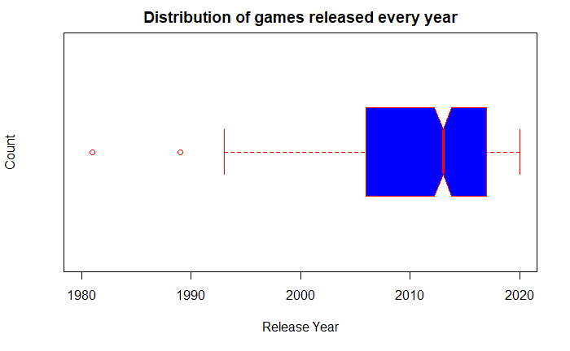

**Figure 2. Histogram**

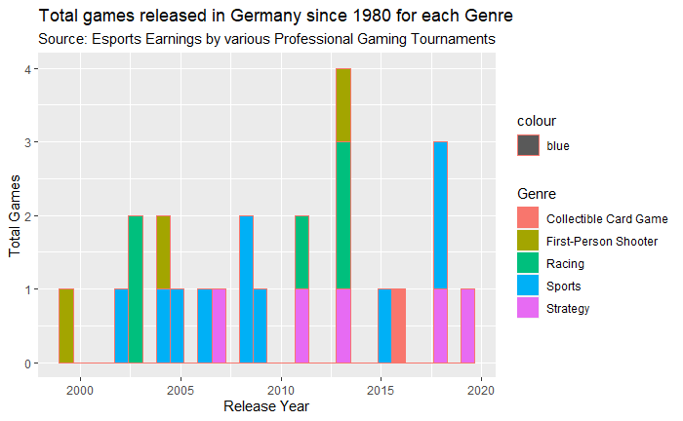

**Figure 3. Violin Plot**

